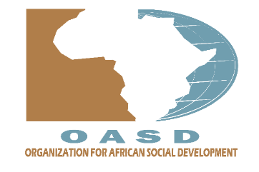**LIST OF OASD PROJECTS SINCE 2022**

**TO BE USED FOR WEBSITE ARTICLES.**

|  |  |  |  |  |  |
| --- | --- | --- | --- | --- | --- |
| S/NO. | PROJECT NAME | PARTNERS | DONOR | SECTOR | DETAILS IN SHORT |
|  | IYER CULVERT INSTALLATION PROJECT | ENG.ORYEM JOHN SPEKE.  REDR UK.  UGANDA INSTITUTION OF PROFESSIONAL ENGINEERS.  MAKERERE CEDAT. | - | TRANSPORT |  |
|  | ATAPARA CULVERT INSTALLATION PROJECT | ENG.ORYEM JOHN SPEKE.  REDR UK.  UGANDA INSTITUTION OF PROFESSIONAL ENGINEERS.  MAKERERE CEDAT. | - | TRANSPORT |  |
|  | IYER BOREHOLE PROJECT. | - | THE STIRLING FOUNDATION [thestirlingfoundation.org](https://thestirlingfoundation.org) | WASH |  |
|  |  |  |  |  |  |
|  |  |  |  |  |  |

**PROJECT NAMES AND ARTICLES**

**1. IYER CULVERT INSTALLATION PROJECT**:

Donor: REDR UK

Sector: TRANSPORT

Partners: ENG.ORYEM JOHN SPEKE, UGANDA INSTITUTION OF PROFESSIONAL ENGINEERS ([uipe.co.ug](https://uipe.co.ug)), MAKERERE CEDAT.

In 2022 The Organization for African Social Development (OASD) alongside Eng. Oryem initiated a culvert restoration project in Iyer village in Agago. This project was identified to close the gap in transportation and connectivity for the people of Iyer. The bridge on the road connecting Iyer villages to the main road was facing tremendous flooding in the rainy season. As such the community was unable to use the road submerged in water.

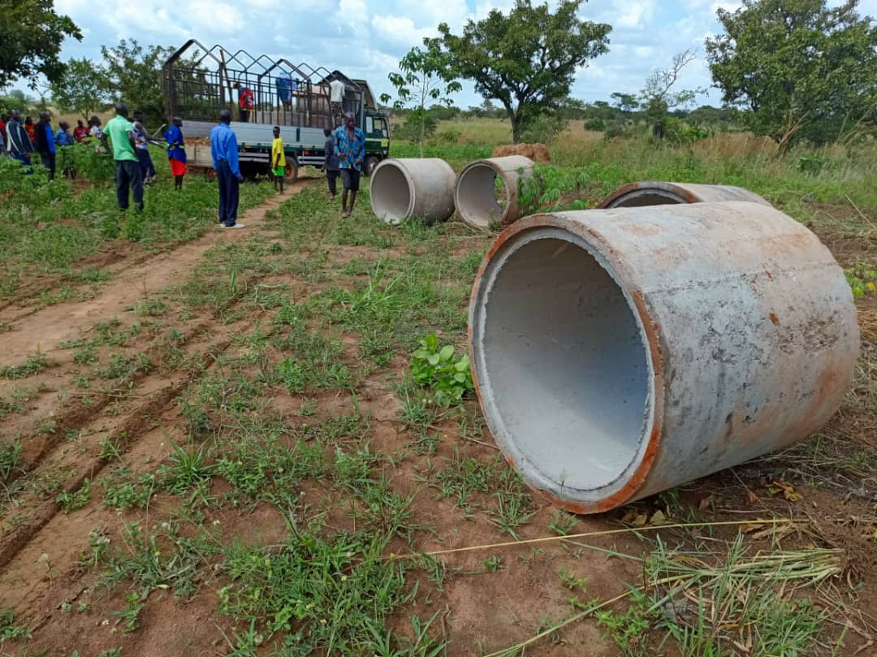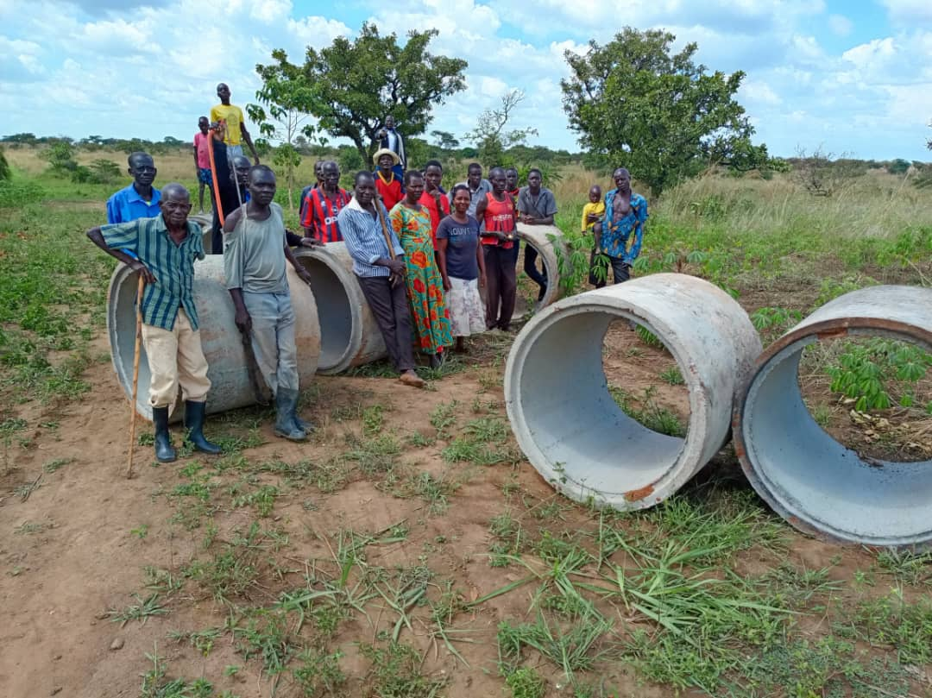

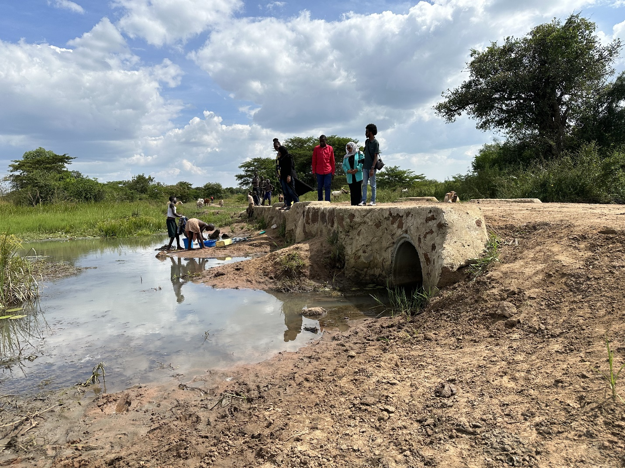

The project therefore identified this problem and suggested installing a better culvert to the bridge and designing a better drainage system near the swampy place. The project therefore diverted the water and constructed a new bridge at the point. This enabled the community to remain connected to the main towns and main road despite the weather.

A total of ….. In the villages of people were impacted by this project in the village as students can now cross the road, farmers can access markets and other needs.

2. **ATAPARA CULVERT INSTALLATION PROJECT**:

Donor: REDR UK

Sector: transport.

Partners: ENG.ORYEM JOHN SPEKE, UGANDA INSTITUTION OF PROFESSIONAL ENGINEERS ([uipe.co.ug](https://uipe.co.ug), MAKERERE CEDAT.

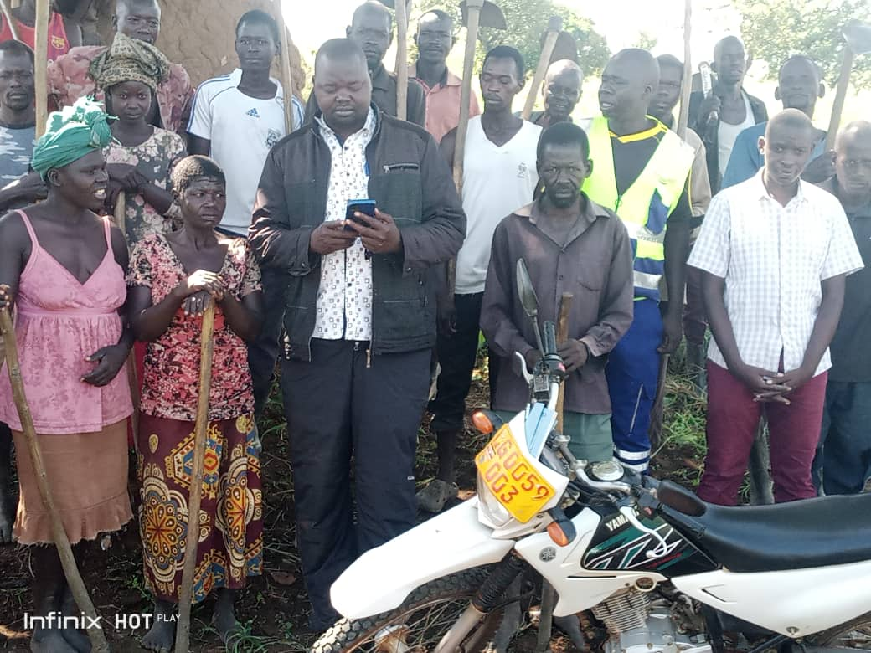

**A photo showing community member after the work of opening the access roads to enable equipment access the site during drilling.**

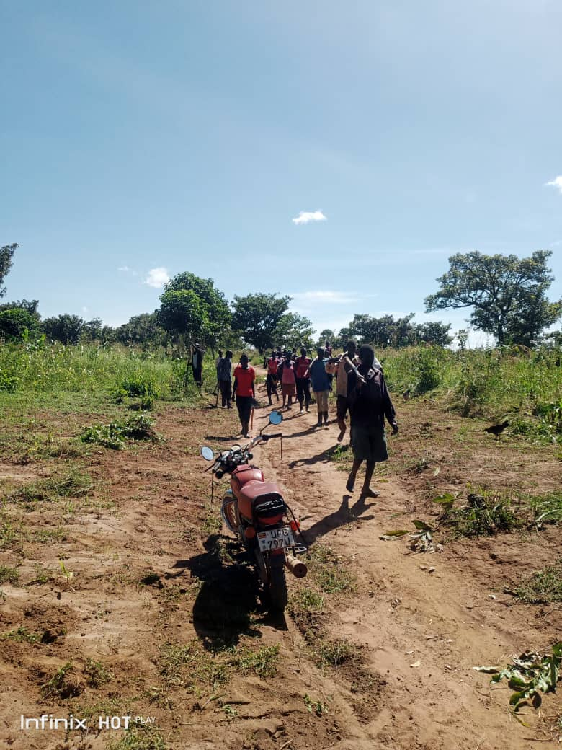

**Photo showing community members that are participating in opening the roads**

Upon the successful installation of the Iyer culvert, Redr UK awarded Engineer Oryem alongside The Organization for African Social Development (OASD) alongside Eng. Oryem another opportunity to identify a need in Iyer and thus provide a solution. With consultation with the community, we embarked on another culvert installation project in Iyer village in Agago. This time the project identified to construction of another road connection between Iyer villages alongside the installation of culverts on Atapara Swamp. This project will cover the gap in transportation and connectivity for the people of Iyer.as the communities will be connected.

The project is ongoing and roads works a now complete… The project will divert the water at swamp and construct a new bridge at the point. This will enabled the entire community to remain connected to the main towns and main road despite the weather.

A total of 1,284 in the villages of people were impacted by this project in the village as students will now be able to cross the road, farmers will access markets and other needs

3. **IYER BOREHOLE WATER PROJECT**:

Donor: THE STIRLING FOUNDATION.

Sector: WASH (Water, sanitation and hygiene)

Partners: no partners.

Location of Project

• Village: Iyer Tekulo

• Parish: Lukee

• Sub-county: Kotomor

• District: Agago

• Region: Northern Uganda.

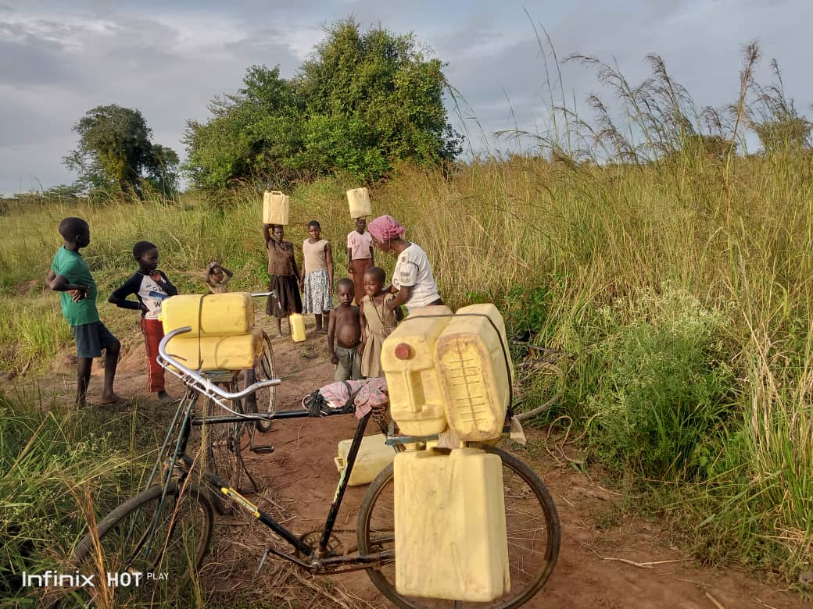

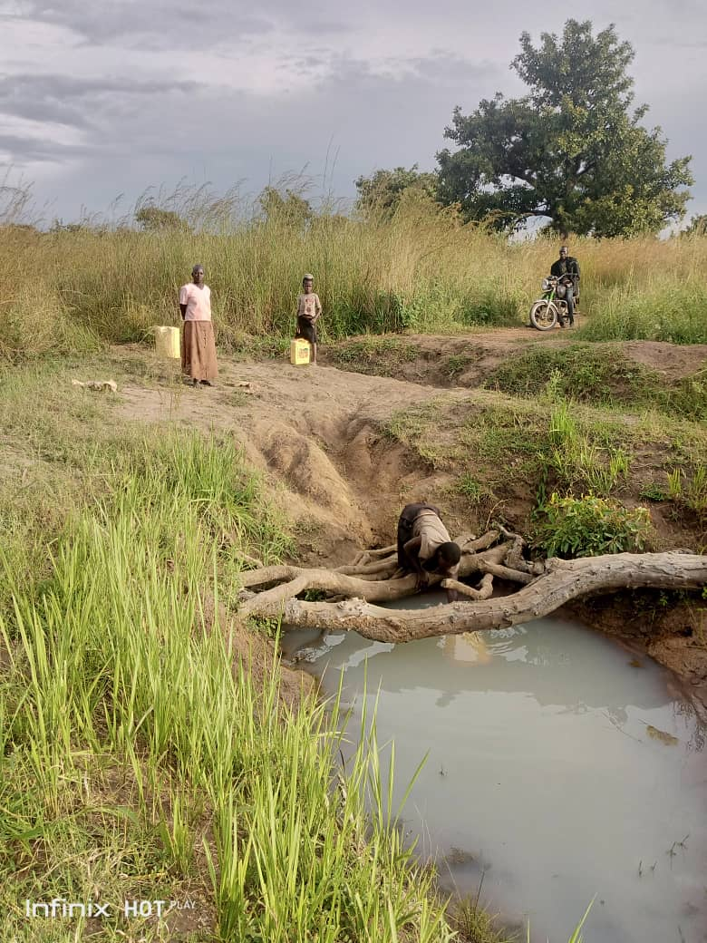

**A photo showing one of the three shallow wells used by the community as a main source of water.(field photo)**

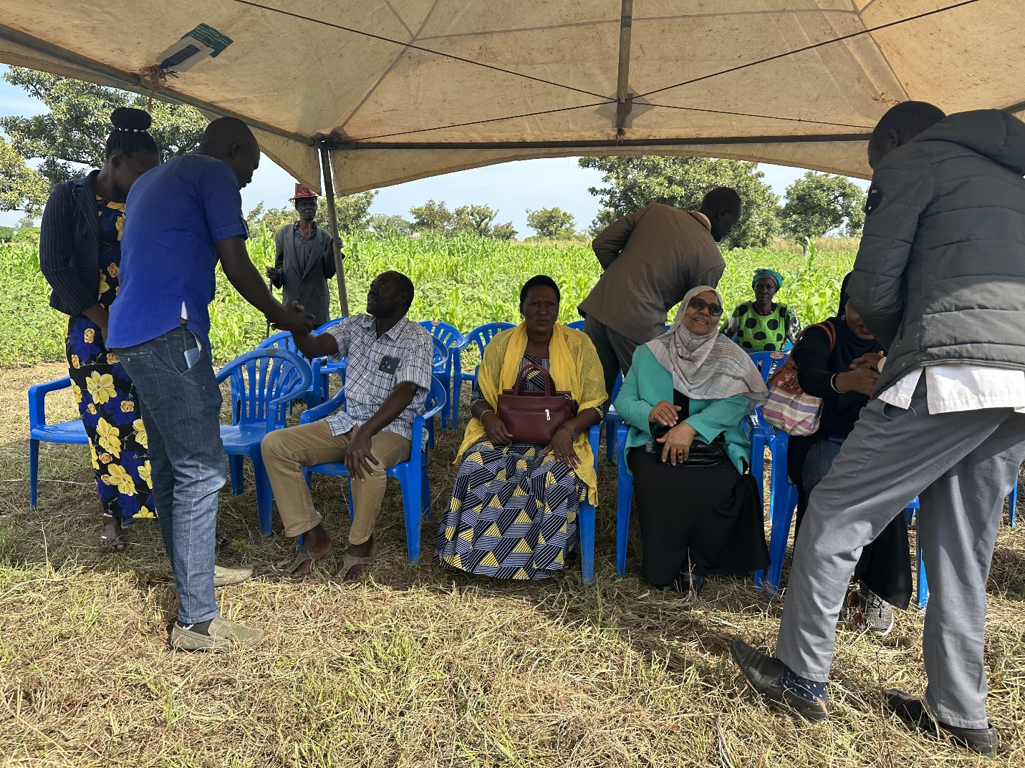

The communities of Iyer face many challenges that are brought about by the lack of a safe, reliable and accessible water source for domestic and production uses. The residents of Iyer rely on the use of few seasonal swamps that surround the two villages of Iyer for all their water needs. These swamps, especially in heavy rains, are submerged by flash floods and always contaminated by cattle and agricultural farm activities. School-going girls and women spend averagely 4 hours daily trekking long distances and queuing up to collect water from the swamps hence loss of productive hours in search for water.

The local people approached our NGO to help them solve the water crisis problem in the villages of Iyer. With the funding form Stirling, after carrying out a feasibility study, we found that Iyer has abundant underground water resources

The proposed a solar-powered water pumping system for the Iyer water supply and irrigation project. This water project, equipped with a liters (5m3) capacity water tank will therefore address the problem of the lack of a safe, reliable and accessible water source in Iyer community. The project will relieve 1,284 people from the burden of looking for clean water, improve sanitation and promote household incomes hence improved welfare and livelihood. The water will be used for domestic uses that include but not limited to drinking, washing, bathing, cooking and cleaning. Other households will use for watering of home gardens and the upkeep of domestic animals.

**4.**

**5.**

**6.**

**LOGOS OF PARTNERS**

MAKERERE CEDAT

REDR UK

UGANDA INSTITUTION OF PROFESSIONAL ENGINEERS

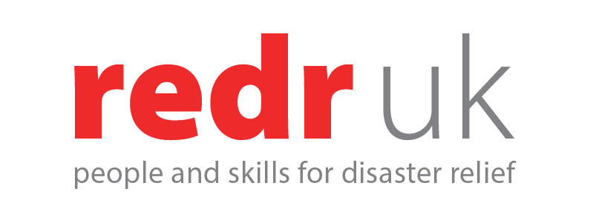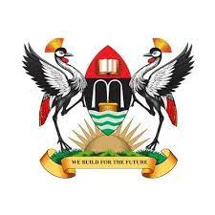

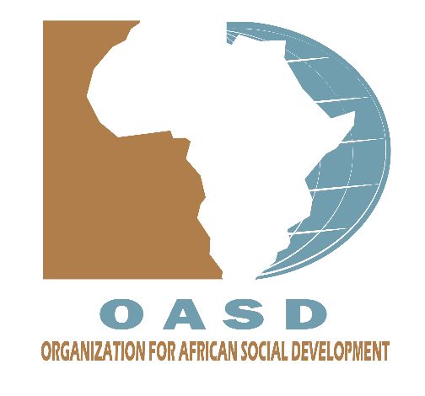

**ONE PARAGRAPH BRIEF**

**Education** is the cornerstone of individual and societal development, providing the necessary knowledge and skills for personal growth and societal progress. It empowers individuals to contribute meaningfully to their communities and adapt to an ever-changing world.

**Health** is a fundamental aspect of well-being, encompassing physical, mental, and social dimensions. Accessible and quality healthcare ensures that individuals can lead fulfilling lives, free from preventable diseases and ailments.

**Emergency relief** plays a crucial role in responding to unforeseen crises, providing immediate assistance to those affected by disasters, conflicts, or other emergencies. It aims to address the urgent needs of individuals and communities, offering shelter, food, and medical aid during critical times.

**Culture**, on the other hand, shapes the identity of societies, preserving traditions, fostering creativity, and promoting diversity. It serves as a unifying force, fostering a sense of belonging and understanding among people, enriching their lives and connecting them to their shared heritage.

**OR**

**EDUCATION** is at the forefront of our African development agenda, aiming to expand understanding and foster dialogue. We are committed to providing a trusted platform for planning and building enduring partnerships among local communities, states, civil society, and international organizations. Our focus is on delivering basic and necessary services with a special emphasis on a social protection approach. Through comprehensive and inclusive social protection initiatives, we seek to reduce poverty, vulnerability, and inequality while increasing resilience to risks and promoting access to services and the labor market. We believe that education is a key driver for sustainable development, empowering individuals and communities to thrive in an ever-evolving world.

In the realm of **HEALTH**, our mission is to secure, deliver, and increase access to safe drinking water, basic education, nutrition, and health services, particularly in rural areas. Our goal is to improve livelihoods by decreasing malnutrition and mortality rates. By addressing family, women, and child protection issues, especially in humanitarian situations such as conflicts and trafficking, we strive to build inclusive and effective Social Protection Systems that prevent and respond to violations, ensuring the well-being of vulnerable populations.

**EMERGENCY RELIEF** is a critical aspect of our efforts, focusing on providing immediate assistance to those affected by disasters and conflicts. We aim to catalyze strategic solutions for sustainable development while offering shelter, food, and medical aid during critical times. Our approach emphasizes building smart partnerships between stakeholders to enhance social stability and foster economic growth in the face of unforeseen crises.

**CULTURE** is woven into our development fabric, with a commitment to promoting and preserving the rich diversity of African heritage. We recognize the significance of culture in shaping identities and fostering creativity. Through our initiatives, we aim to empower families, women, and children for full and equal participation in political, civil, economic, social, and cultural life at local, national, regional, and international levels. We believe that by building partnerships and networks among local communities and various organizations, we can collectively advance the cultural dimension of sustainable development in Africa.

**DIRECTORS OF OASD.**

|  |  |  |  |
| --- | --- | --- | --- |
| Faridah Nalugua Kulumba | Ugandan | Social worker | kuluma.faridah@oasd.africa |
| Mohamed Ahmed Musa | Sudanesse | Social worker | musa.mh@oasd.africa |
| Suad Eltahir Abdalla | Sudanesse | Social worker | Suad.abdalla@oasd.africa |



